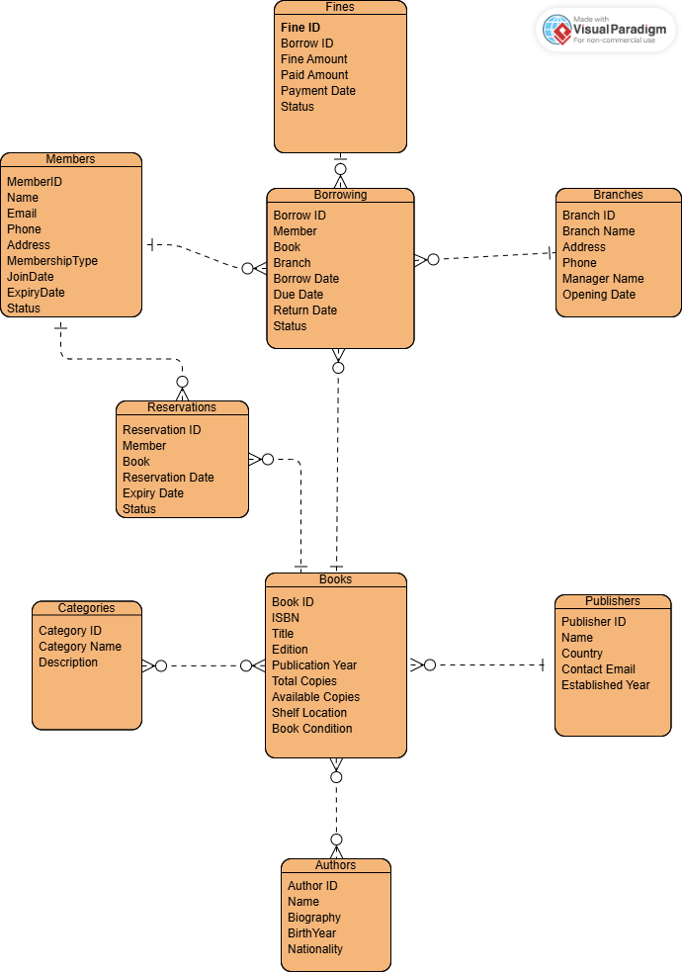
Task 1: ERD Design

Task 2: Normalization

 | Issues | Example
1NF | repeating values | author_names = "Alice Smith, Bob Jones" → two authors in one cell  categories = "Fiction, Drama" → two genres in one cell
2NF | Partial dependency | member_name depends only on member_id
3NF | transitive dependencies | publisher_country depends on publisher_name, not on the table key.

Task 3: Database Mapping
